**Pending Prescription Report**

“Pending Prescription Report” is useful to know the list of the patients whose prescription is pending.

So that user can call patient and ask for medicine delivery/Sales.

1. Select “Pending Prescription Report” Menu Path :-Reports-> Pharma Retails Reports--> Pending Prescription.

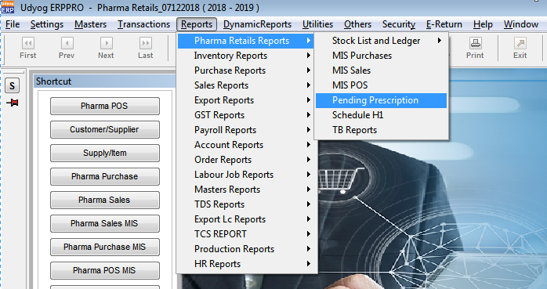

1. Create 2 patients as shown below :

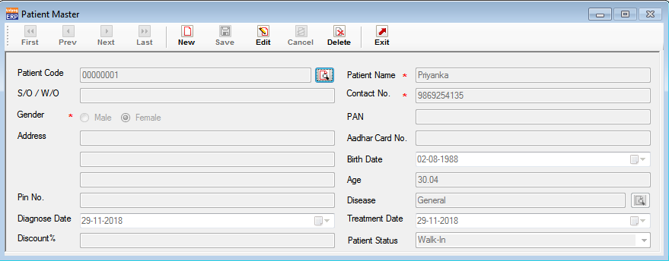

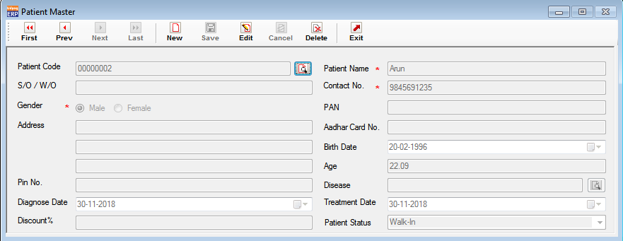

1. Create 2 doctors as shown below :

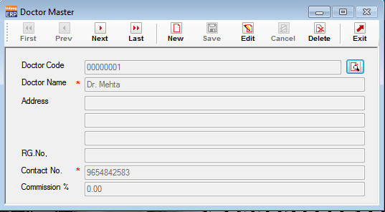

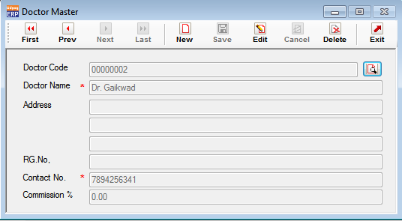

1. Create 1 medicine in Supply Master as shown below :

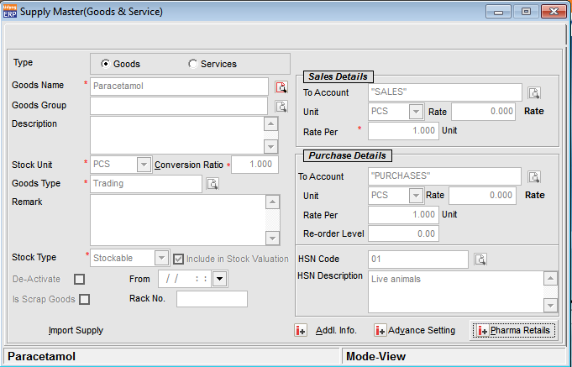

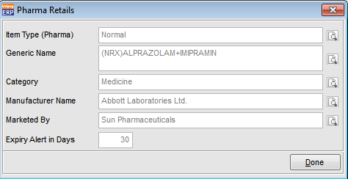

1. Create 4 Prescriptions for the 2 patients on various prescription dates and 2 doctors selection as shown below :
2. Prescription 1

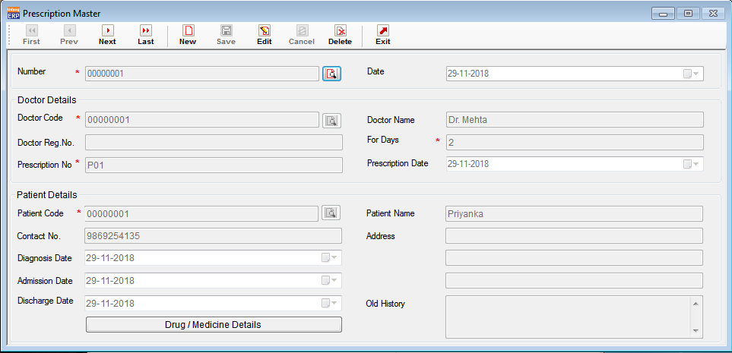

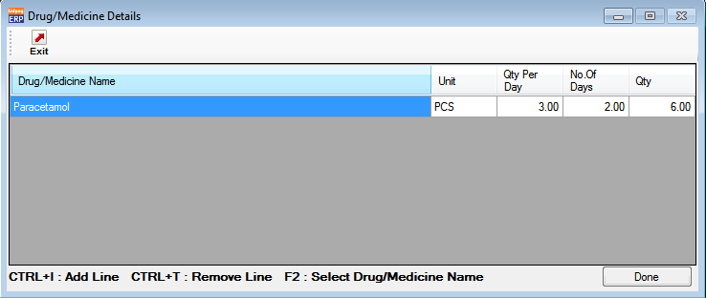

1. Prescription 2

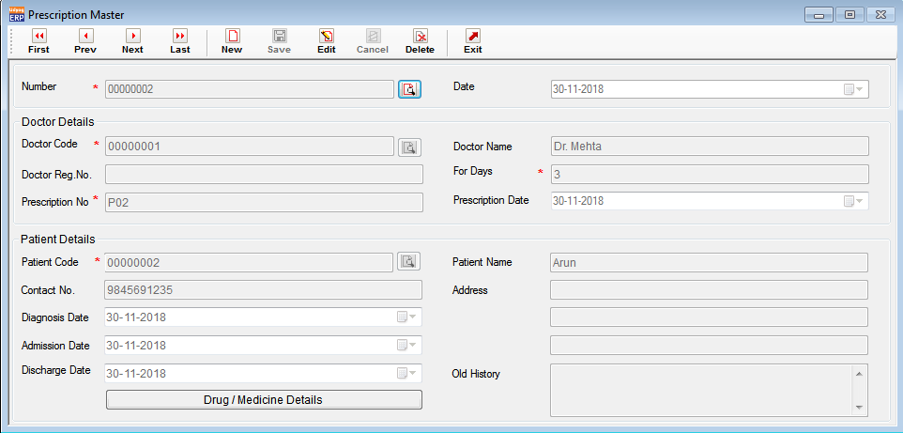

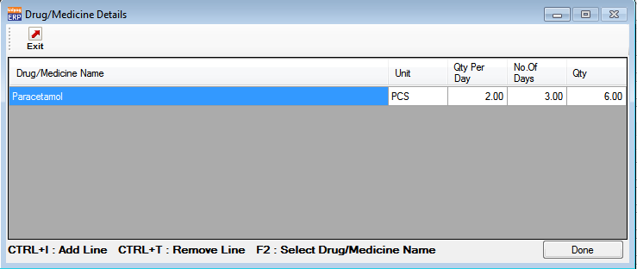

1. Prescription 3

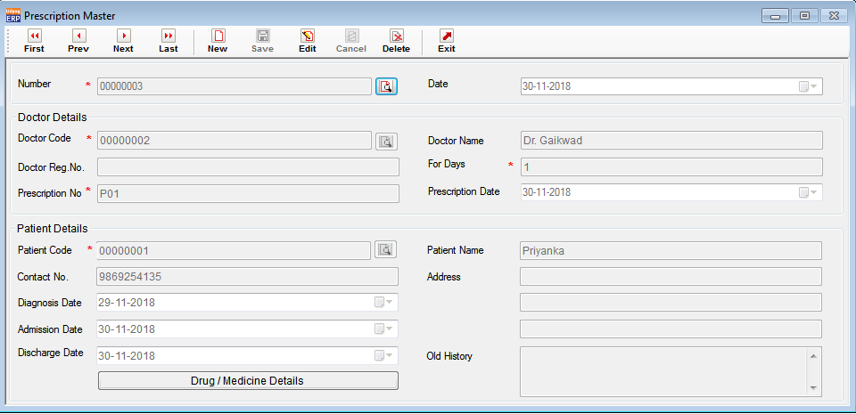

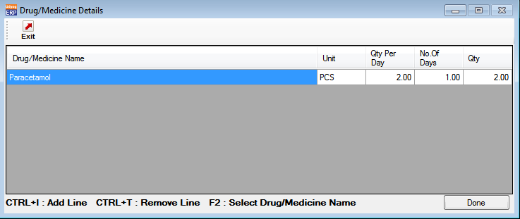

1. Prescription 4

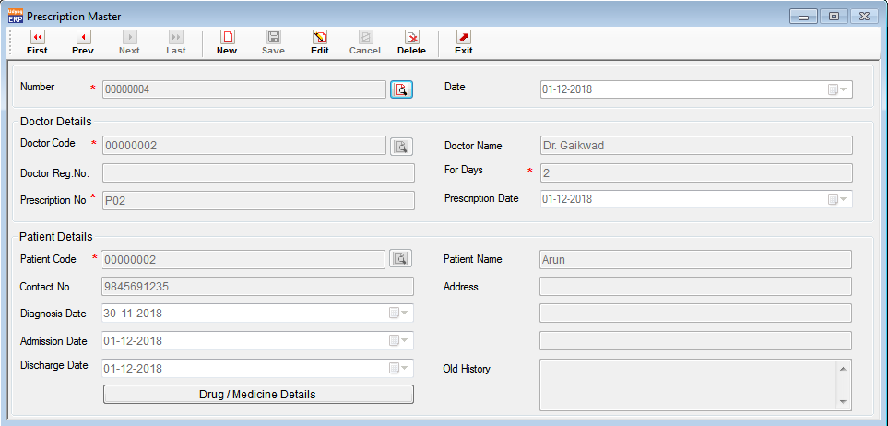

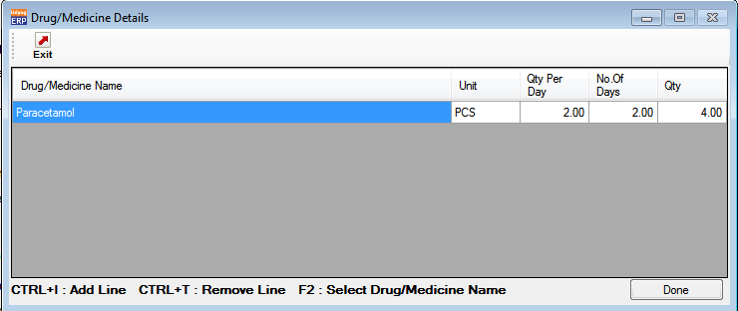

1. Done POS on 29-11-2018 for Prescription 1

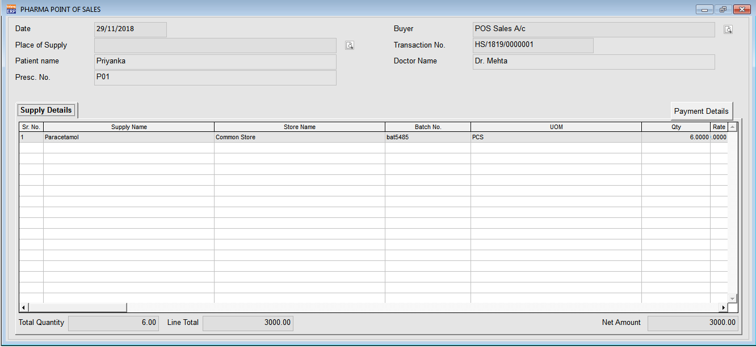

1. Done POS on 30-11-2018 for Prescription 2

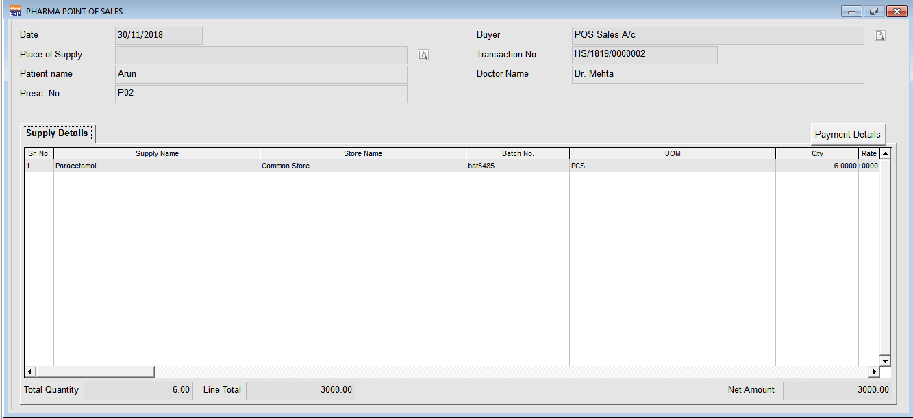

POS related to Prescriptions 1 & 2 is done on 29-11-2018 & 30-11-2018 itself & its For days is 2 & 3 days respectively.

So for Prescription 1 next date to purchase medicines is on 01-12-2018 and for Prescription 2 next date is 03-12-2018.

As Prescription 3 is created but not done POS so it comes under pending prescription report shown below upto 30-11-2018.

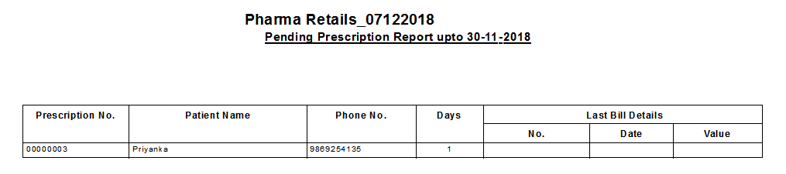

Below report shows prescriptions pending upto 01-12-2018 with last bill details :

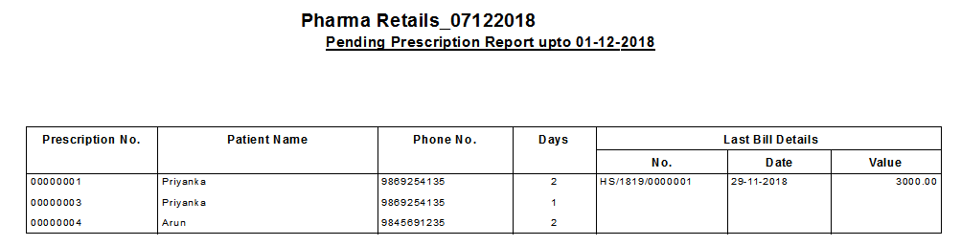

Below report shows prescriptions pending upto 03-12-2018 with last bill details :

